Sri Lanka Institute of Information

Technology



Lab Submission

Lab sheet No.6

**IT23329560**

**Palihaderuarachchi W S**

**Probability & Statistics | IT2120**

B.Sc. (Hons) in Information Technology

**Exercise**

1)

i) What is the distribution of X?



ii) What is the probability that at least 47 students passed the test?

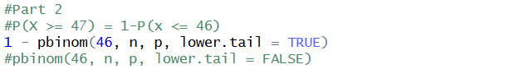



2)

i) What is the random variable (X) for the problem?

ii) What is the distribution of X?

 iii) What is the probability that exactly 15 calls are received in an hour?

